Student Skill Development Management System
Program – Output
Submitted by: T.Rupendra (192311325)
G.Mohammad shareef(192311288)
Ch.Sathish(192311032)
K.Manjunadha Reddy(192372081)

1. Full Console Transcript
==========================================================================================
STEP 1: Seeding database with sample students, skills, target roles, assessments
==========================================================================================
Seeded 8 students and 6 skills.

==========================================================================================
STEP 2: View Student Skill Profile — Aditi Sharma
==========================================================================================
Communication score= 41 level=Intermediate (as of 2026-03-16)
Data Structures score= 63 level=Intermediate (as of 2026-03-16)
Problem Solving score= 55 level=Intermediate (as of 2026-03-16)
Python Programming score= 57 level=Intermediate (as of 2026-03-16)
SQL & Databases score= 47 level=Intermediate (as of 2026-03-16)
Teamwork score= 61 level=Intermediate (as of 2026-03-16)

==========================================================================================
STEP 3: Skill Gap Analysis — Rahul Verma -> Data Analyst
==========================================================================================
Python Programming required= 70 current= 78 [MET]
SQL & Databases required= 75 current= 54 [GAP = 21 points]
Communication required= 60 current= 57 [GAP = 3 points]
Problem Solving required= 65 current= 54 [GAP = 11 points]
--> Role readiness: 25.0%

==========================================================================================
STEP 4: Progress Trend — Sneha Iyer, Python Programming
==========================================================================================
2026-01-15: 56
2026-02-14: 54
2026-03-16: 58

==========================================================================================
STEP 5: Cohort Leaderboard — Overall Average Score (Top 5)
==========================================================================================
1. Sneha Iyer 59.0
2. Arjun Rao 58.3
3. Karan Mehta 57.4
4. Priya Nair 56.9
5. Divya Menon 56.9

==========================================================================================
STEP 6: Leaderboard — SQL & Databases (Top 3)
==========================================================================================
1. Sneha Iyer 68.0
2. Karan Mehta 65.0
3. Priya Nair 63.0

==========================================================================================
STEP 7: Cohort Skill Distribution (avg score per skill)
==========================================================================================
Communication avg= 54.2 (n=8 students)
Data Structures avg= 48.1 (n=8 students)
Problem Solving avg= 54.6 (n=8 students)
Python Programming avg= 62.0 (n=8 students)
SQL & Databases avg= 53.1 (n=8 students)
Teamwork avg= 60.1 (n=8 students)

2. Rendered Terminal Screenshot (excerpt)
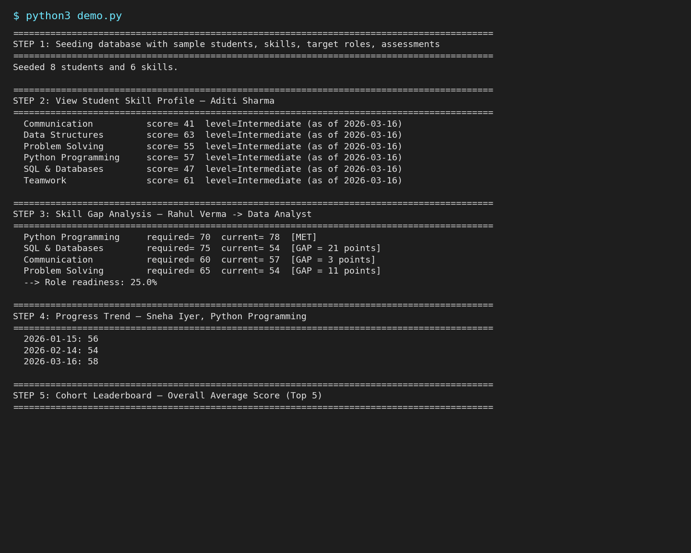

3. Generated Charts (also used in the Report)
